Your full name

Phone 1/ phone 2

Your email id
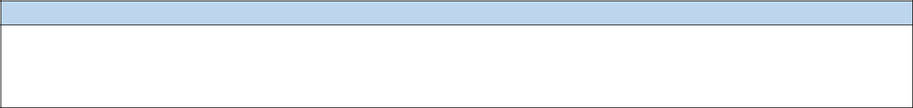

Objective

To obtain a position that will enable me to use my educational background, analytical skills, ability to work with people and give positive contribution to the organization.
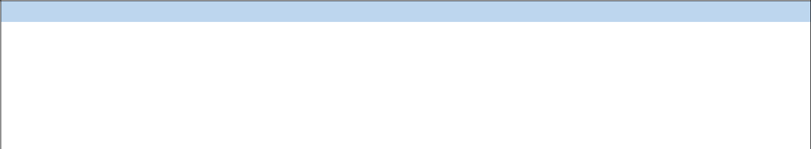

Educational Qualifications
 |  | MBA ( Data Science) | School of Data Science & Forecasting, |  |  | 80.05 | 2017-19
 |  | MBA ( Data Science) |  |  | DAVV, Indore(M.P) | 80.05 | 2017-19
 |  | BE(CS) |  | Medicaps Group of Institution, |  | 70 | 2013-17
 |  | BE(CS) | Indore(M.P) |  |  | 70 | 2013-17
 |  | (XII) |  |  | JPS Academy | 72 | 2013
 |  | (X) |  |  | St. Raphael’s Girls H. S. School | 82 | 2011
 |  | Project
 |  | P1. To test effectiveness of online advertisement and analysing its impact on sales.
 |  | Programming Language |  | : | Python
 |  | Technologies |  | : | Machine Learning
 |  | Tools |  | : | Anaconda Navigator
 |  | Project Description |  | :

The aim was to test the effectiveness of advertisement (online) and predicting clicks by defining the relationship between different factual variables thereby analysing change in sales of the company.

P2. Number plate detection system.

Programming Language | : | Python
Technologies | : | Machine Learning
Tools | : | Anaconda Navigator
Project Description | :

The aim was to manage and monitor traffic system by identifying traffic rule breakers.

Skills

Languages: Python , R
IDE: Anaconda, Rstudio

Database: MySQL, NoSQL

Tools: MsExcel, SPSS, Weka, Tableau

Internship / Practical Training:

Imparted training for Enterprises Resource and Planning (ERP), Revenue Management System(RMS) at M.P.Paschim Kshetra Vidyut Vitran Co. (MPSEB).

Distinctive Highlights

Secured state rank 1st in 4th National Cyber Olympiad.

Extra co-curricular Activities

I was a member of Organising committe of International IEEE conference held at medicaps.

Personal Information

Date Of Birth | : dd/mmn/yyyy
Father’s name | : Fathers Name
Mother’s Name | : Mothers Name
Permanent Address : Address with Pin Code
Languages known | : Lang1 and Lang2
DATE: | Your Name
PLACE:

